Press Kit
Nationwide Theatrical Distribution in the Republic of Ireland by

Buena Vista International

May 2002
Parent International
presents
a
PFJ
production
Peter Caffrey Michael Roper

NEW 14’ 32” CINEMA CUT!
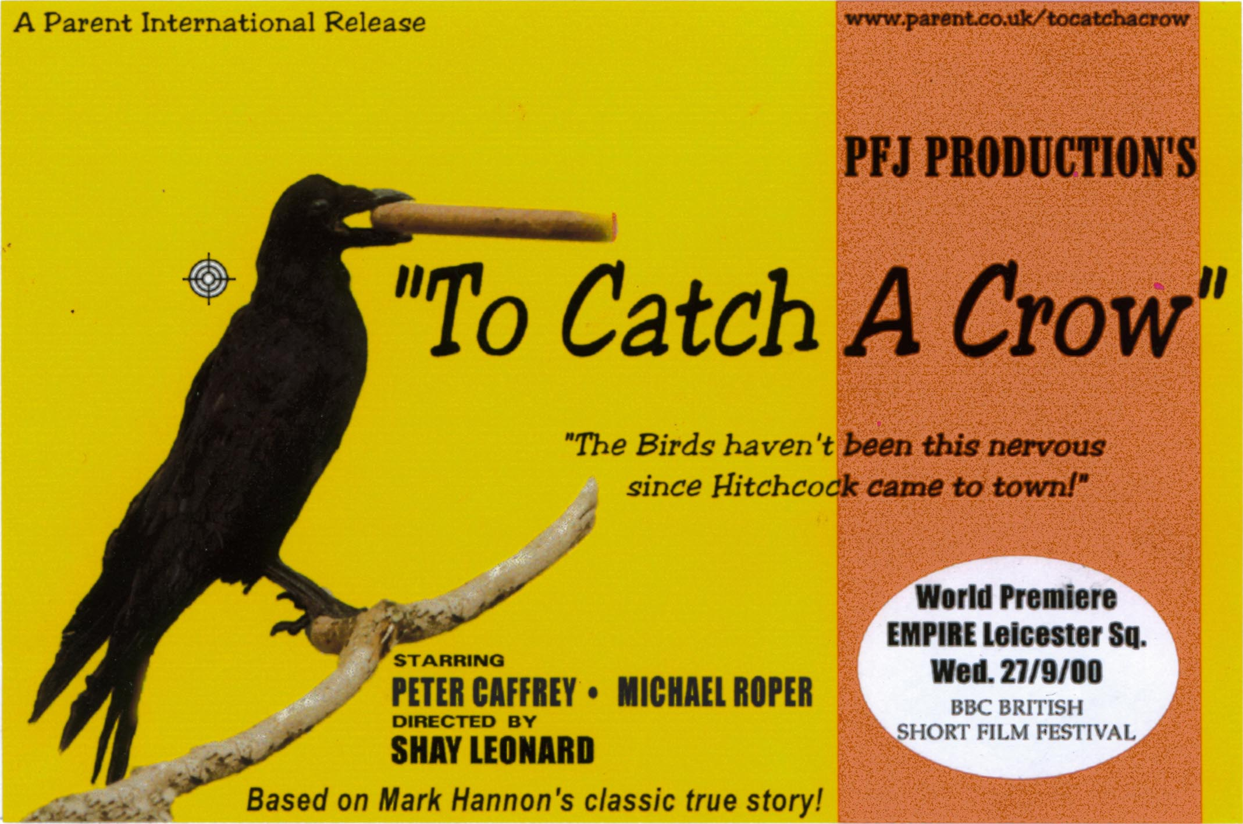
WINNER
Red or Dead
Audience Award
BBC British Short
Film Festival
Shortlisted for the BAFTA Kodak European Short Film Showcase at Cannes
www.parent.co.uk/tocatchacrow

A PFJ Production "To Catch A Crow" starring Peter Caffrey Michael Roper
Robert Hopkins Lionel Gallagher Florie Moffitt and introducing Johnny as 'the pig'
Dog Handler Ashling McHale Clapper/Loader Marcus Taglienti Boom Operator Steve Reddy
Production Driver Denise Haugh Executive Producers of Food Paul Gibbons Suzanne Leonard
Production Design Assistant Emmelena Harrison Runners Cian Collins Sara Fox
and Other Very Important People Who's Names Don't Look As Good In Narrow Fonts
Written, produced & directed by Shay Leonard

"To Catch A Crow"

Winner
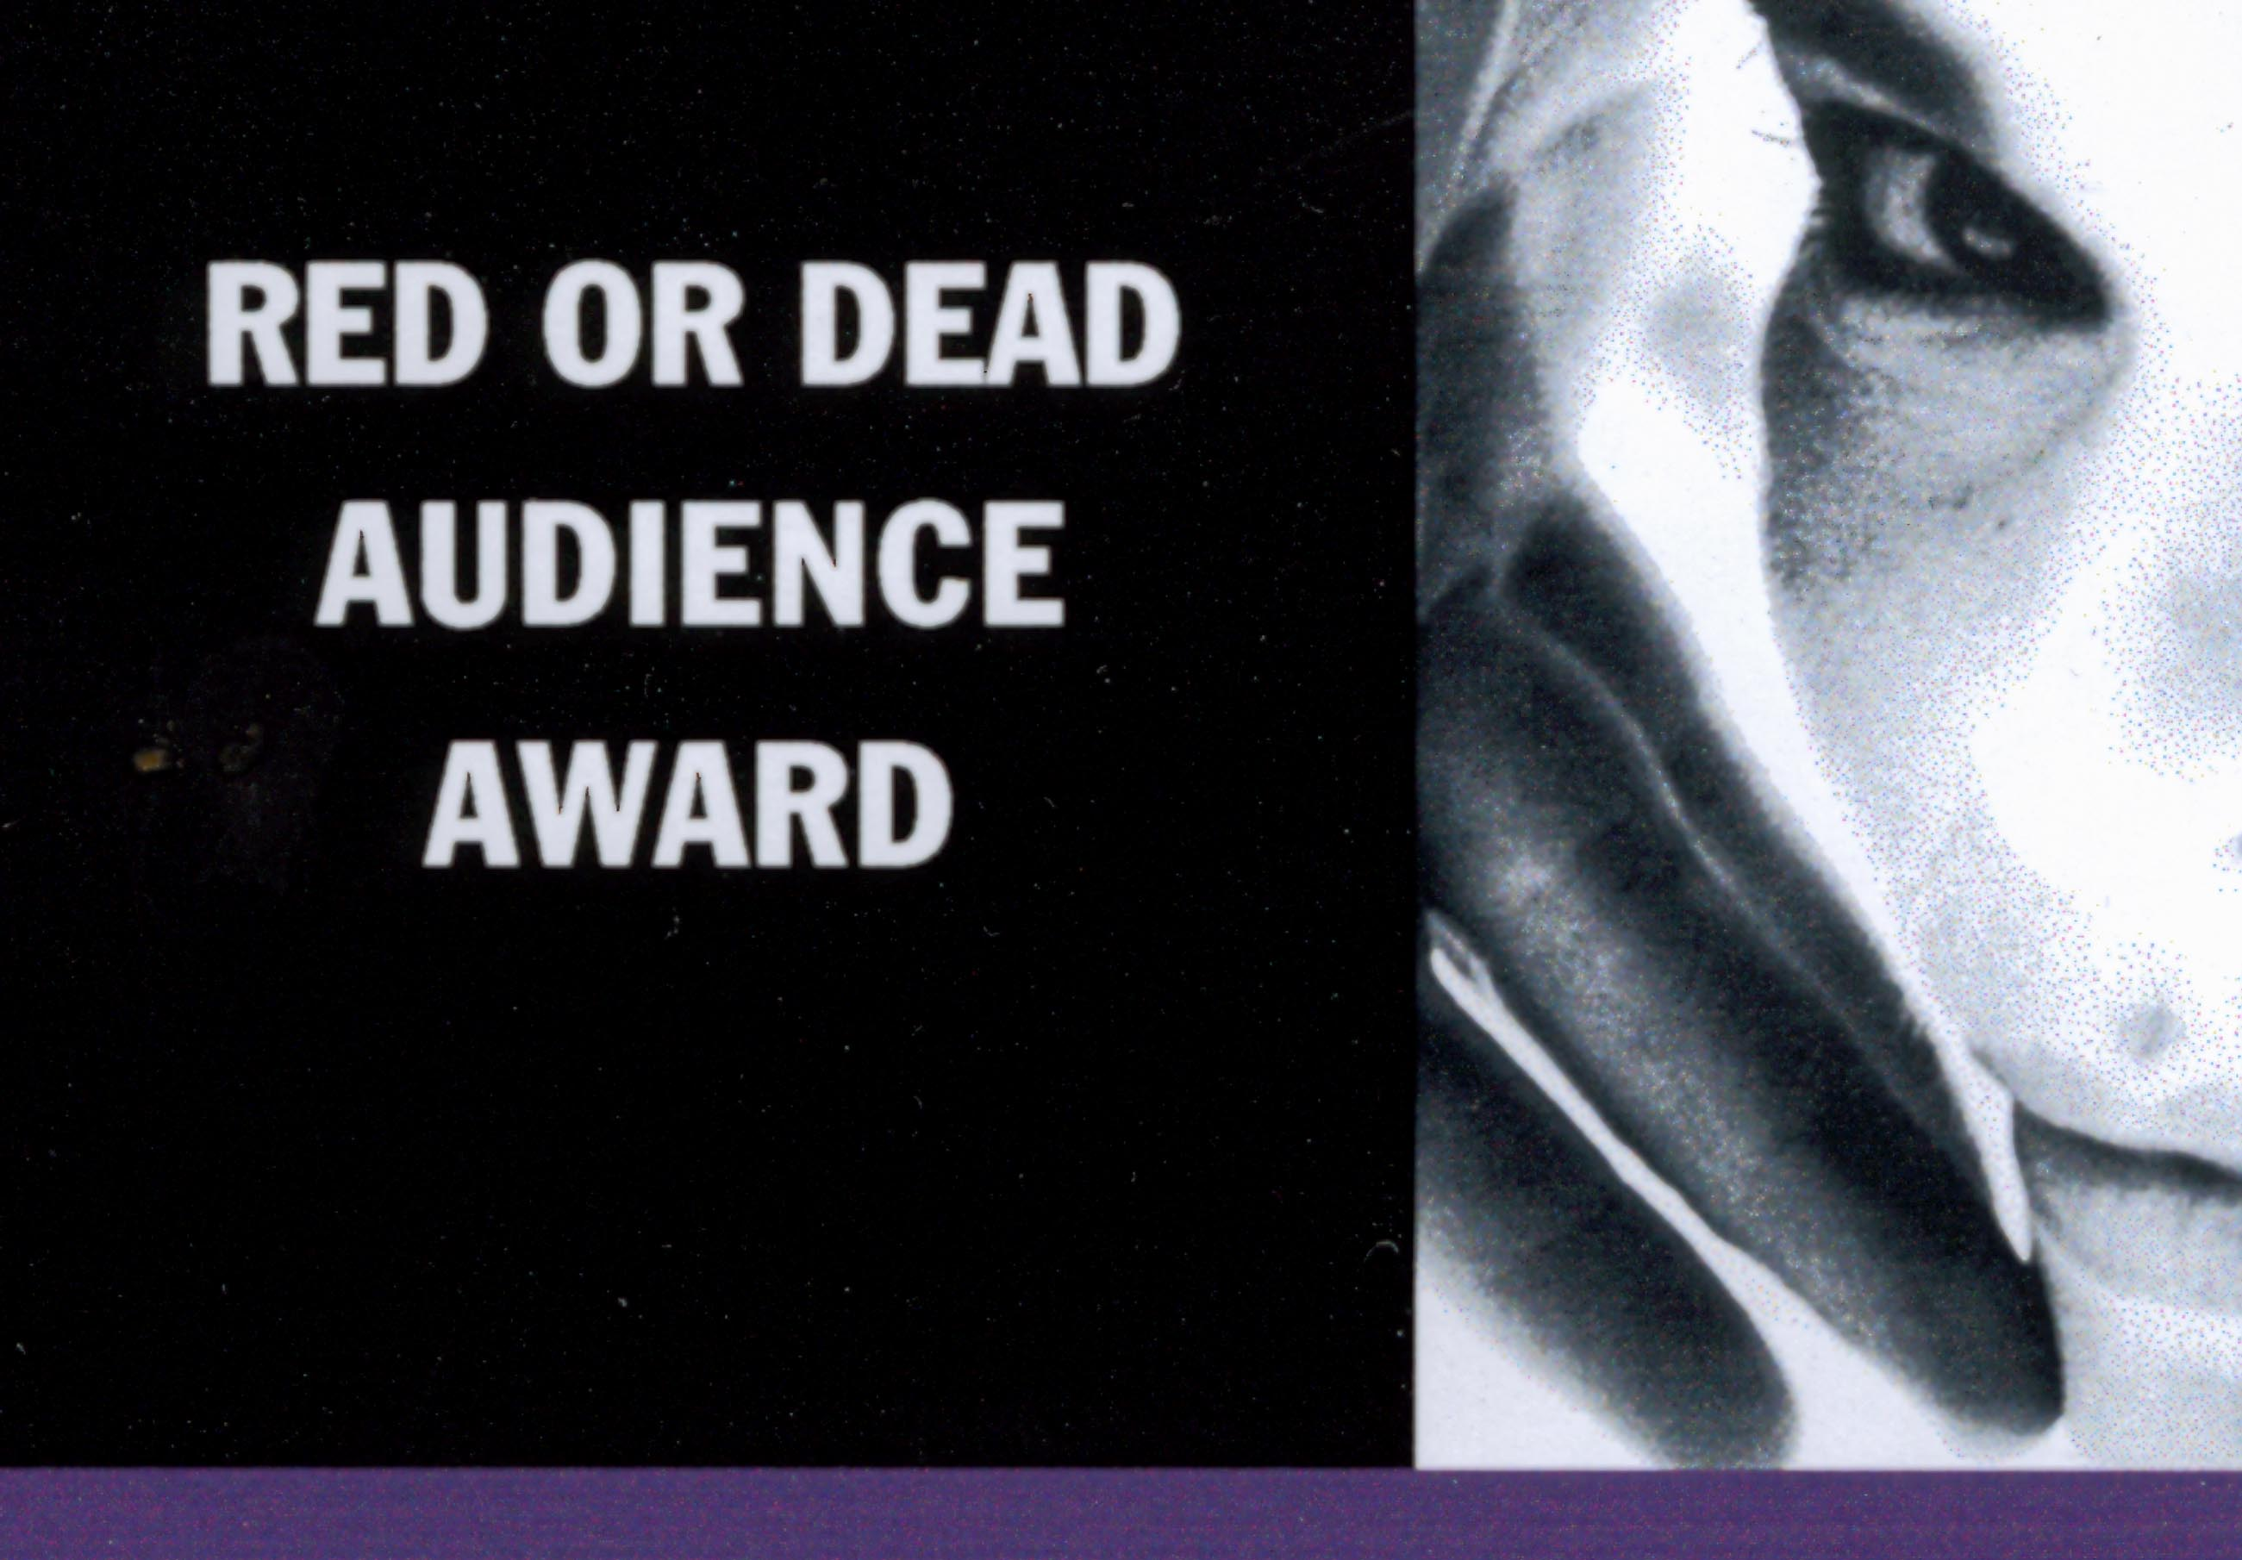
BBC British Short Film Festival
______

Nationwide Theatrical Distribution in the Republic of Ireland by
Buena Vista International

Spring 2002

68 dean street, london, W1D 4QJ, UK.
t: +44 (0) 777 555 8970
f: +44 (0) 777 555 9014
e: info@parent.co.uk

PFJ Productions
47 york way, london n7 9qf, england
tel/fax: +44 (0) 20 7485 3432
mob: +44 (0) 966 166 460
email:shay@pfjproductions.freeserve.co.uk

Introduction

• To Catch A Crow is a 20 minute comedy drama shot on Super 16mm colour film in the north-west of Ireland, in Autumn 1999.
• The story is based on actual events that took place in Sligo in the late '70's, during the last time the region was featured in a film. Thus, the location of the film serves to highlight this beautiful yet neglected area of the country.
• To Catch A Crow is a high quality short film that aims to transfer the rich Irish art of storytelling onto the cinema screen.
• To Catch A Crow is a strong visual comedy that will appeal to a broad audience world-wide.
• To Catch A Crow serves as a taster for a feature film entitled 'Turf', to be shot in the same area with the same lead characters.
• Peter Caffrey, star of Ballykissangel, I Went Down, and Fr. Ted, stars in the lead role of 'Paddy' in the film.

Story Synopsis

A pompous English film crew arrive in a small village in County Sligo, in the north-west of Ireland to shoot a feature film. All the villagers want a part in the movie, or to make a few quid from the production, including PADDY, a local farmer. Unfortunately, PADDY's acting talents leave a lot to be desired, but then MARTIN, the props master, comes to PADDY and his brother JOE, looking for a crow to use in the film. The brothers manage to catch a few crows, but the demanding film Director wants a yellow beaked blackbird. The blackbird proves to be a very difficult catch, and before long the whole village is out searching for the elusive bird. As time runs out before the shoot, the panic stricken film crew keep increasing the bounty on the head of the blackbird, and crow hysteria takes over the whole village...but who will catch the bird?

Notes on Production

Origins

The story of To Catch A Crow began in Cliffoney, Co. Sligo, in the late 1970's. An English film crew came to town to make a feature length TV drama for BBC Northern Ireland entitled "Yer Man from the Six Counties" and produced by Oscar winning writer Colin Welland. Local farmer Mark Hannon was approached by one of the film crew for some animals to use in the production. Cattle, pigs, hens and various farmyard animals are no problem, but when a live crow was requested......the fun started.

Flash forward 20 years to Christmas 1997 and London based Dublin film maker Shay Leonard sits in a kitchen in Cliffony listening to Mark Hannon recounting the hilarious story of the 'crow incident' while on a visit to the area. Shay takes up the story, "I had been working on a feature length script based on two local farmers for production in Sligo, and after hearing Mark's fantastic story I decided to make it into a short script, the idea being to use my two characters in the lead roles, thus providing a platform to introduce the characters within a short film format."

On return to London Shay begin to write the script; Mark's story provided many of the necessary ingredients for the two farmers, then, all that was required was some work on the English film crew side. For Shay this task was aided by having spent over 4 years working on films and television in London. "The ridiculousness of film crews has always fascinated me, they expect the world to stop when the camera is rolling. They take over peoples houses and streets, most of them walking around with inflated egos and delusions of grandeur. I thought this attitude would provide a nice contrast to the relaxed demeanour of the local characters."

Having finished the first draft of the script in relatively short time, the task of finding a producer and finance proved to be more of a headache. The script was sent to various Irish production companies, and while the responses were encouraging, short scripts in Ireland are "two for a penny these days", and finding a suitable producer dedicated to spending time on the project was very difficult. Similarly, the various grant and funding boards proved impregnable.

Undeterred, Shay decided to produce himself, raising the finance through his own work in TV and film in England, and through local businesses in the Sligo region. A year later and after several visits to Sligo the necessary finance for the shoot was finally in place and Shay returned to Dublin to begin pre-production.

Casting

Peter Caffrey first heard about To Catch A Crow in the summer of '98, having received the script through his London agent. Peter loved the story and immediately dedicated his support to the project, and luckily was available to come to Sligo for the weeks shooting. Local theatre actor Michael Roper had just returned from a tour in the States and also committed himself to the film. The remainder of the cast were found through Letterkenny casting company Munro Casting, and through articles in The Sligo Champion newspaper requesting local talent.

To Catch A Crew...

For Shay the task of finding a full crew was daunting. "I've been in London for twelve years, and many of the people I regularly work with were very interested in coming over to work on the film, yet when it came down to committing to the shoot almost everybody was working on some 10 week feature or another, so the chances of them coming over to Ireland to work for free for a week were pretty much nil". Once in Dublin Shay begin putting the word out about the film, and after six weeks of phone calls, "sorry not available", coffees, beers, driving around, and "I'd love to's", the crew was finally in place.

The shoot was scheduled to begin on Monday 27th September, and everybody began arriving up to the area over the weekend. "One of the most important factors for me was getting a crew and cast who would get on with each other. Unlike a city shoot where everybody goes there own way at night, we would be living in each other's hair for 8 days - so we had to get on. I was also very aware of the life imitating art issue - getting a film crew in to make a film about an obnoxious film crew....so everybody had to be good people, no bullshit". This worry was also reflected in the local pub's landlady, who wasn't quite sure whether everybody would be "asking for exotic drinks like Pimms", and be full of airs and graces. As it turned out nobody needed to worry, the crew got on with each other and the locals like two crows in a nest.

Spag Bol?

Another concern was food and lodging. Short films are renowned for cutting corners, and catering and accommodation budgets are generally the first to be trimmed. "Nobody was getting paid, so I thought the least we could do was to feed them well, and give them a comfortable bed at night. We hired out two holiday homes, Jesus, they were nicer than my flat, the Sound Man was definitely happy - he'd spent 6 weeks on the floor of a disused abattoir in Germany on one film! For the food we got two really good chefs and didn't skimp on the budget. They provided three options for dinner, unheard of on a short, and were better than most of the £5m.+ productions that I work on in England."

Shooting the crows

The shoot went with very little hiccups. The weather, worldwide renowned for its 'changeable' tendencies in the North West was remarkable. A seven day shoot, and the sun shined every day...with the exception of one, when weather cover saved the day. The locals all became involved, helping out behind the scenes, and over 30 managed to get their faces on camera. A charity pub quiz was organised by Peter Caffrey on the second last night of the shoot, effectively providing a pre-wrap party, raising local spirits and over £450 for the local Cancer Hospice.

Pre-rehearsal time had been limited, and the all important relationship between the two brothers Paddy and Joe developed very quickly over a few nights spent in the local. By the end of the week Peter Caffrey and Michael Roper had most of the locals convinced that they were indeed brothers! Yet they were upstaged in the film by local actress Florie Moffitt who plays Finula, their Housekeeper. 68 year old Florie had never seen a film camera before in her life, yet took to it like a natural. Watch out Hollywood, Florie's on her way.

Locations

Many people had suggested shooting the film in Wicklow, or even in the English Home Counties, yet Shay wanted the story to be true to it's origins. "Paddy and Joe's house and garden were actually the real locations where the events of 20 years previous took place. The kitchen, the net between the two trees, the chimney, are all the exact places where the original story occurred." The vast exteriors of Sligo have not been seen on film since "Yer Man From The Six Counties", and they provided a unique backdrop to the action.

Post Production

The post production on the film was completed with the help of many people in London. Berkeley Cole of Remote Films offered his post production facilities free of charge, and Alex McDonnell spent many long hours putting the final cut together. In an effort to steer away from any 'diddly-eye' soundtrack, London band Gallon Drunk were drafted in to provide the jazzy soundtrack. As with many low budget short films director Shay Leonard became chief post production runner on the project, racing around with boxes under his arms between the post production facilities in Soho and West London for months on end, whilst producer Alexis Bicât spent weeks on the phone convincing very expensive facilities houses to offer their services for free.
Key Crew Profiles

Shay Leonard (Director & Producer)
Shay Leonard is an Irish film-maker who has been making low/no-budget short films and videos in London for over ten years. Shay studied film at the University of North London, and at the City University of New York and the University of Toulouse in France. In 1996 his graduation video The Present Occupier: Final Demand was premiered at the Portobello Film & Video Festival in London.

Since graduating in 1996 Shay has been working on short and feature films in London, including the highly successful Lock, Stock, and Two Smoking Barrels by Guy Richie, Hunting Venus by Martin Clunes and the forthcoming feature films Five Seconds To Spare by Scala Pictures, and Sexy Beast by the Recorded Picture Company. He has also worked on many television productions such as the BBC's Maisie Raine, Harry Enfield, and How Do You Want Me?

Shay's film work has been mainly in the Art Department, yet he has also assistant directed, and worked as a camera operator. He has written a feature length black comedy entitled 'Turf' that is also based in Sligo. "To Catch A Crow" represents Shay's first work on Super16mm, shooting with a full crew.

Alexis Bicât (Co-Producer)
By training as a film director Alexis graduated from the University of North London (UNL) in 1995. It was here that Alexis and Shay Leonard first began to work together. As part of his degree Alexis spent a year making films in New York at the City University of New York (CUNY) in Harlem. Alexis has directed and produced nine short films. His works include many never before seen movies that deal with sometimes taboo themes that touch many of us in today’s world.

In autumn 1996 Bicât launched the highly successful SOHO SCREENINGS Film Market. Since then Bicât has been indirectly involved in the sale of well over thirty feature films, encouraging producers to go it alone in the world of sales. THE SOHO SCREENINGS stands as a mark of his determination, interest and commitment in helping to nurture, encourage and display new filmmaking talent.

In 1999 he successfully brokered a two year sponsorship deal with Kodak Professional Motion Imaging that gives five new independent feature films per year a place in THE SOHO SCREENINGS for free. At 1999’s SOHO SCREENINGS Bicât received much praise in Variety, Moving Pictures and The Hollywood Reporter for launching a working database driven web site that unified the registration process for Buyers and Sellers attending the pre-MIFED event at a stroke.

Joanne O' Hagan (Production Manager)
Joanne began working with Graph Films as an Assistant Producer in 1993. She was consequently a Producer with Midas Films from 1995 to 1997 working on various broadcast, corporate and pop promo productions. For the past two years Joanne has produced and directed numerous short films, television programmes, and corporate video presentations for RTE and other Irish companies in a freelance role.

James Cotter (Director of Photography)
Since graduating from Dun Laoghaire College James has been lighting both short drama films and corporate projects. He has also directed his own short film "Life on Mars", broadcast in August 1999 on Network 2 as part of the 'Debut' series. His most recent work was the short "Nowhere Land".

Robert Flanagan (Sound Recordist)
Robert is also a graduate from Dun Laoghaire, and has developed his sound skills by working with some of the country's top sound mixers. He has worked on over 40 short films and many feature films throughout Ireland. In October 1999 he achieved the rare distinction of winning two BAFTA Technical Awards for sound composition and design. Robert has also received awards at the Galway Film Fleadh and the FUJI Short Film Awards in London.

Alex McDonnell (Editor)
Educated in Liverpool Alex rose quickly through the ranks to become the in-house editor for Remote Films in Battersea, London. A position he has held for more than 5 years. Now a director of the company Alex likes nothing more than the work he does on low budget dramas. His experience extends well into short films, pop promos, commercials, documentaries and corporate videos.

James Johnston & Gallon Drunk (Original Music)
Gallon Drunk's dark, boozy rock & roll became a cult favorite in the U.K. in the early '90s. The band formed in London in 1990, releasing singles on their own Massive record label. Gallon Drunk have played the UK gig circuit for over ten years, with lead man James Johnston also touring with Nick Cave and the Bad Seeds during the early 90's. Their early singles received favorable reviews and the band signed with Clawfist records in 1992. Gallon Drunk released their first major label record, From the Heart of Town, in 1993, and have since released 4 albums. In recent years the band have turned to soundtrack composing, initially for short films yet they have just had their first original soundtrack CD released to accompany the Greek feature film "Black Milk". Their strong impact on the soundtrack recording world has been comfirmed with the recently completed score for the feature film “The Most Fertile Man in Ireland”.

Key Cast Profiles

Peter Caffrey ("Paddy" Character)\
As a regular on Ballykissangel over 5 series, Peter is one of the 'familiar faces' of the production. In recent years he has also appeared in Channel 4’s Fr. Ted , the acclaimed low-budget Irish feature I Went Down, and the BBC’s A Love Divided. He also features in the highly acclaimed feature Night Train (1999) with John Hurt. Peter agreed to play the leading role of "PADDY" in the film having greatly admired the script.

Michael Roper ("Joe" Character)
Michael is somewhat of a latecomer to film, having acted on stage for over 25 years, taking the lead in plays varying from many of the Irish Classics to contemporary works such as 'One Flew Over The Cuckoo's Nest'. He recently starred in the Donegal shot short film 'Charlie's Mission'.

Rob Hopkins ("Martin" Character)
Most recently directed and played "Gerry Evans" in Friel's "Dancing at Lughnasa" for KDG Theatre Co. "A peerless production" - Main Event RTE. Currently working on two short films and a pilot radio soap...
"The Clown's Lament" with Dublin based Juanita Wilson, "The Tidiest Town in Ireland" (Munster Films) & "The Last Resort" Radio Corca Baiscinn (Eire)

FORMAT OF PRINT

35mm Married Optical Release Print
Aspect Ratio 1:1.85
Sound Dolby SR
Running Time 15’19”

Credits

The PFJ for this production were…

Cast

Paddy McGovern Peter Caffrey
Joe McGovern Michael Roper
Martin Robert Hopkins
Finula Florie Moffitt
Old Mikey Lionel Gallagher
Dave "The Producer" Jon Bodhrá
Director Roger Barton Smith

Additional Cast

TV Presenter Pat Gibbons
Card Player Joe Haris
Card Player Tom Walsh
Woman in Pub / Auditioner Ita McMorrow-Leyden
2nd Woman in Pub Maureen Connelly
Audition Performer Christopher Callery
Audition Performer Mairéad Clancy
Audition Performer Gerry Ryan
Animal Safety Officer Dr. John Mark Dick
Film Crew Member Jim Bishop
Pall Bearers Big Joe Gilmartin
Cian Collins
David Holland
Mark Dunne
Guard Eugene McHale
Hunter Mark Hannon

Crew

Writer/Director/Producer Shay Leonard
Co-Producer Alexis Bicât
Executive Producers Shane Munro
Patrick Durkan
Director of Photography/
Camera Operator James Cotter
Sound Recordist Robert Flanagan
Editor Alex McDonnell
Music James Johnston
with Ed Rose & Ian White

Casting Munro Casting / Daphne O'Connor
Production Manager Joanne O'Hagan
Production Co-ordinator Ruth Thomas
Assistant Co-ordinator Emer Regan
Additional Script Inspiration Celia Coyle
Script Supervisor Taylor Segrest

Stills Photographer Mary McDermott
First Assistant Director Noirin Hennessey
Second Assistant Director Lesley Ann Shaw
Third Assistant Director Gethan Dick
Set Runner Cian Collins
Set Runner Sarah Fox
Focus Puller Louise McEllin
Clapper/Loader Marcus Taglienti
2nd Unit Director of Photography Will Henshaw
2nd Unit Camera Operator Trevor Forrest
Gaffer Howard Gibson-Steel
Lighting Technician Gannon Murphy
Lighting Tech./Dolly Grip Síle O'Dwyer
Lighting Technician David Holland
Boom Operator Steve Reddy
Art Director/Props Buyer Ciara Draper
Construction Manager Sean Gibbons
Art Dept. Assistants Mary McDermott
Emmelena Harrison
Caroline Clancy
Dermot Blighe
Storyboard Artist Ollie Roberts
Taxidermist Val Campbell
Dog Handler Ashling MacHale
Crow Handler Paul Kelly
Costume Designer Maeve Mooney
Costume Assistant Catherine Brady
Hair/Make-up Artist Oonagh Dowling
Hair/Make-up Artist Lisa Corcoran
Set Driver (& Unit Winnebago!) Imelda Brady
Production Driver Denise Haugh
Driver Kieran Carty

Catering "Gibbo's Angels"
Suzanne Leonard
Liz Meahan
Paul Gibbons
Sound Editor Paul Cotterell, Lipsunc
Telecine Co-ordinator Rob Dunne / Vidfilm Europe
Neg Cutter TruCut
Film Grading CFS
Music Supervisor Adrian McKinney
Titles Lee Robinson
Titles Transfer Screen Opticals
Insurance Sedgwick Dean
Vehicle Insurance IPM
Courier City Air Express
Laboratory CFS, London
Camera Equipment Ronan Fox
VFG, Ireland
Grip Equipment Concorde Anois Teo
Lighting Equipment Cine Electric
Film Stock Photologic / Kodak Ireland
Photocopier Cantec (Northwest) Ltd.
Radios Universal Arms

Extras extraordinaire

Celia Coyle
Mary Gorevan

Paul Kelly
Fran Carroll
Margaret McCartney
Shona Costello
Jim McDermott
Steve Cunningham
Siun McDermott
Diana Diamond
Niamh McHale
Tracey Diamond
Sinead McHale
Damien Gildea
Cormac Meehan
Paul Gildea
Emma Meehan

Ross Gildea
Liz Meehan
Tina Gildea

Maureen Meehan
Jim Leonard
Paddy
Stella Leonard
Alan Roper
Sharon Marshall
Anne Roper

Christopher McBride

Emma McCartney
Denise Haugh
Gibbo
Catriona Flynn
Oscar the dog
Johnny the pig (RIP)
& Most of the crew ...

Very Special Thank You to…

Michael Mullaney & Michael Quigley, Mullaney’s Soliciors, Sligo
Cormac Meehan, Sean Meehan & Co. IAVI, Bundoran
Ronan MacConUisce, Shoot The Crows, Sligo
Berkeley Cole & all at Remote Films, London
Jim & Stella Leonard
Mary McDermott

Pat Gibbons

Thanks also to

The Beach Hotel, Mullaghmore

Atracta Boyle, Harbour View Holiday Homes
Columba Henneghan, Concorde Anois Teo

Claire MacHale

Steve Kyte, CFS

Gorevan’s Pub

The Canavaun Lounge

Mary Feeney

James Foy

Jim Gray, The Sligo Champion

Martin Reilly Motors, Sligo

Ronnie Gillanders, Auctioneer, Sligo

Guinness, North West Sales

Hire & Sell Centre, Bundoran

Garda, Cliffoney

Jimmy McAuley, City Air Express
David McGowan, McGowan’s Funeral Services, Ballina

Packie & Kathleen Harrison

Joe Kelly

Gerry Burns

Michael, Telegael

Mick O’Toole, Cine Electric

Mary Davey, Davey’s Pub

Sligo County Council

Estelle Robin

Irish Distillers

Catherine Hayward

Print support costs by / Bord Scannán hÉireann/The Irish Film Board

Dolby SR Licence supplied by Dolby Laboratories UK Ltd.

Sound Post Production by Lip Sync Post

Grateful Thanks to David Freeman

Much gratitude to
Mark Hannon, the original storyteller, crow catcher, and local hero!

No animals or birds were harmed specifically by / on behalf of the film makers in this production.
(although most of the crew did feast on the beast and dine on the swine throughout the shoot)

Thank you to the residents and businesses of Cliffoney

Shot on location in and around Cliffoney, Co. Sligo, Ireland

©PFJ Productions 2000

This film is dedicated to the memory of
Uncle Paddy & Gorevans Pub

Paddy & Joe will return in
Turf

